- Copyright for test papers and marking guides remains with West Australian Test Papers.
- The papers may only be reproduced within the purchasing school according to the advertised conditions of sale.
- Test papers must be withdrawn after use and stored securely in the school until June 11



HUMAN BIOLOGY
Unit 3
2021

Name: _______________________________________________________

Teacher: ___________________________________________________

Time allowed for this paper

Reading time before commencing work: ten minutes
Working time for the paper: three hours

Materials required/recommended for this paper
To be provided by the supervisor
This Question/Answer Booklet
Multiple-choice Answer Sheet

To be provided by the candidate
Standard items: pens (blue/black preferred), pencils (including coloured), sharpener, correction fluid/tape, eraser, ruler, highlighters

Special items: non-programmable calculators approved for use in this examination

Important note to candidates
No other items may be taken into the examination room. It is your responsibility to ensure that you do not have any unauthorised material. If you have any unauthorised material with you, hand it to the supervisor before reading any further.
Structure of this paper

Section |  | Number of questions available | Number of questions to be answered | Suggested working time (minutes) | Marks available | Percentage of examination
Section One  Multiple-choice |  | 30 | 30 | 40 | 30 | 30
Section Two  Short answers |  | 9 | 9 | 90 | 100 | 50
Section Three:  Extended answers | 40-41 | 2 | 1 | 50 | 40 | 20
 | 42-43 | 2 | 1
 |  |  |  |  | Total | 100

Instructions to candidates

1. The rules for the conduct of the Western Australian examinations are detailed in the Year 12 Information Handbook 2021. Sitting this examination implies that you agree to abide by these rules.

2. Write your answers in this Question/Answer booklet preferably using a blue/black pen. Do not use erasable or gel pens.

3. Answer the questions according to the following instructions.

Section One: Answer all questions on the separate Multiple-choice answer sheet provided. For each question, shade the box to indicate your answer. Use only a blue or black pen to shade the boxes. Do not use erasable or gel pens. If you make a mistake, place a cross through that square, then shade your new answer. Do not erase or use correction fluid/tape. Marks will not be deducted for incorrect answers. No marks will be given if more than one answer is completed for any question.

Section Two: Write your answers in this Question/Answer booklet. Wherever possible, confine your answers to the line spaces provided.

Section Three: Consists of four questions. You must answer two questions. Tick the box next to the question you are answering. Write your answers in this Question/Answer booklet.

4. You must be careful to confine your answers to the specific questions asked and to follow any instructions that are specific to a particular question.

5. Supplementary pages for planning/continuing your answers to questions are provided at the end of this Question/Answer booklet. If you use these pages to continue an answer, indicate at the original answer where the answer is continued, i.e. give the page number.
Section One: Multiple-choice 30% (30 Marks)

This section has 30 questions. Answer all questions on the separate Multiple-choice answer sheet provided. For each question shade the box to indicate your answer. Use only a blue or black pen to shade the boxes. Do not use erasable or gel pens. If you make a mistake, place a cross through that square, then shade your new answer. Do not erase or use correction fluid/tape. Marks will not be deducted for incorrect answers. No marks will be given if more than one answer is completed for any question.

Suggested working time: 40 minutes.

- Which of the following lists contains only bacterial pathogens?

  - tuberculosis, influenza, tapeworm
  - syphilis, tuberculosis, tetanus
  - tapeworm, tetanus, syphilis
  - influenza, syphilis, tetanus

- Homeostatic control of body temperature is coordinated by which part of the brain?

  - medulla oblongata
  - hypothalamus
  - cerebellum
  - cerebral cortex

- The function of the interneurons is to

  - carry sensory information to the brain.
  - conduct nerve impulses down the spinal cord to lower motor neurons.
  - transmit information between the afferent and efferent neurons.
  - carry sensory information away from the brain.

- Which of the following is a correct comparison of the nervous and endocrine systems?

  - hormones have a rapid action, nerve impulses are slower
  - hormones act on any cells that have receptors for that hormone, nerve impulses act on specific cells only
  - hormones act on the body for a short period of time, nerve impulses act for much longer
  - hormones are electro-chemical messages and nerve impulses are chemical messages

Questions 5 and 6 refer to the table below.

A year 12 Human Biology student measured the resting pulse rate of four of her classmates.

Student | Pulse rate  (beats/min)
1 | 65
2 | 90
3 | 58
4 | 65

- What would the mode be for this set of data?

  - 90
  - 32
  - 65
  - 70

- Which students’ resting heart rate could be considered an outlier?

  - Student 1
  - Student 2
  - Student 3
  - Student 4

- The receptors that detect CO₂ levels in the blood are

  - chemoreceptors.
  - thermoreceptors.
  - baroreceptors.
  - photoreceptors.

- The target organ for the hormone Anti-Diuretic Hormone (ADH) is the

  - liver.
  - bones.
  - bladder.
  - kidney.

- A person who has blood sugar levels below 4.0mmol/L (90mg/100mL) is experiencing

  - type I diabetes.
  - type II diabetes.
  - hyperglycaemia.
  - hypoglycaemia.

- Which of the following would be a correct definition of positive feedback?

  - when the body returns to normal
  - when the original stimulus is intensified
  - when the original stimulus is reversed
  - when the original stimulus cannot be reversed

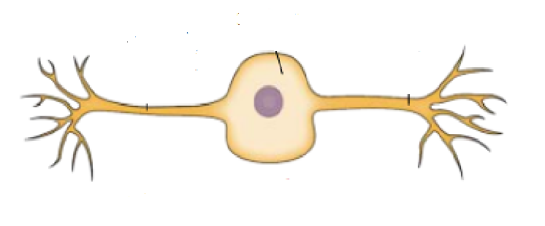

- The neuron shown in the diagram above is

  - a receptor.
  - unipolar.
  - bipolar.
  - multipolar.

- Which of the following is NOT a response that occurs following parasympathetic stimulation?

  - decreased sweat production
  - increased urine production
  - decreased heart rate
  - increase saliva production

Question 13-15 refers to the diagram below.

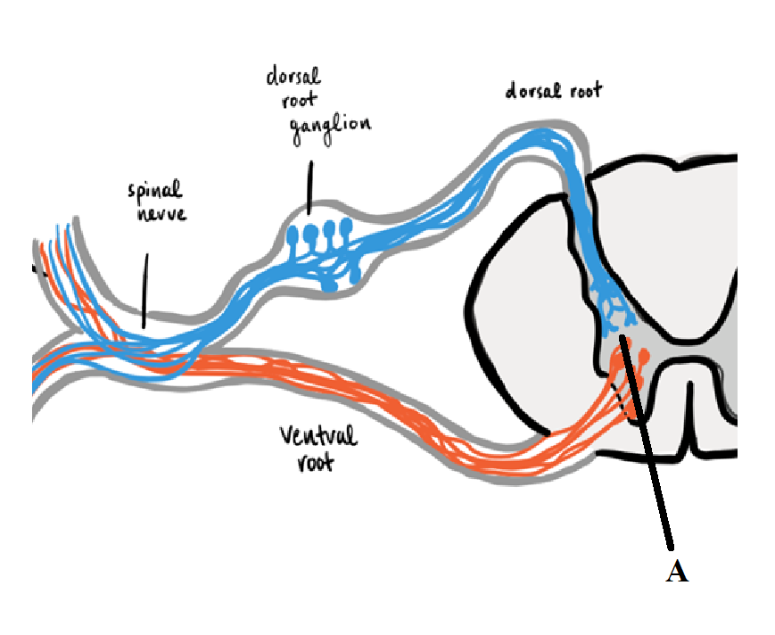

- Which of the following would be found in the dorsal root ganglion?

  - sensory neuron cell bodies
  - motor neuron cell bodies
  - sensory nerves
  - mixed nerves

- What type of neurons would be found at the point labelled A?

  - interneurons
  - unipolar neurons
  - multipolar neurons
  - pyramidal cells

- What would be the effect on a person if the ventral root was severed completely?

  - no effect
  - they wouldn’t be able to feel stimuli or move the part of the body corresponding to the nerve
  - they wouldn’t be able to feel stimuli corresponding to the nerve
  - they wouldn’t be able to move the part of the body corresponding to the nerve

- Which of the following is NOT a function of the myelin sheath?

  - speeds up nervous transmission
  - insulates the axon
  - protects the axon
  - reduces threshold by 5mV

- In which circumstance would memory cells be produced?

  - getting a deep cut
  - a baby receives immunoglobulins in breast milk from its mother
  - a person receives rabies antibodies after being bitten by a stray dog while on holiday
  - a person contracts measles and becomes ill

- What type of vaccine is made up of the living pathogen that has been altered to render it non-virulent?

  - toxoid
  - attenuated
  - sub-unit
  - conjugate

- Which of the following pairings is correct?

  - endocrine gland: ovary; hormone: oestrogen
  - endocrine gland: pancreas; hormone: cortisol
  - endocrine gland: parathyroid: hormone: calcitonin
  - endocrine gland: pineal gland; hormone: thyroid stimulating hormone

- Which is the best definition of a suppressor T-cell?

  - a type of cell that secretes antibodies
  - a type of cells that kills foreign cells, cancer cells and cells infected with viruses
  - a type of cell that stimulates the action of some lymphocytes
  - a type of cell that blocks the action of some lymphocytes to prevent the immune system from becoming over-active

- Which of the following is a correct comparison between B-cells and T-cells?

  - B-cells and T-cells both travel in the blood
  - B-cells and T-cells both stay in the lymph nodes
  - B-cells stay in the lymph nodes and T-cells travel in the blood
  - T-cells stay in the lymph nodes and B-cells travel in the blood

Use the diagram below to answer questions 22-24

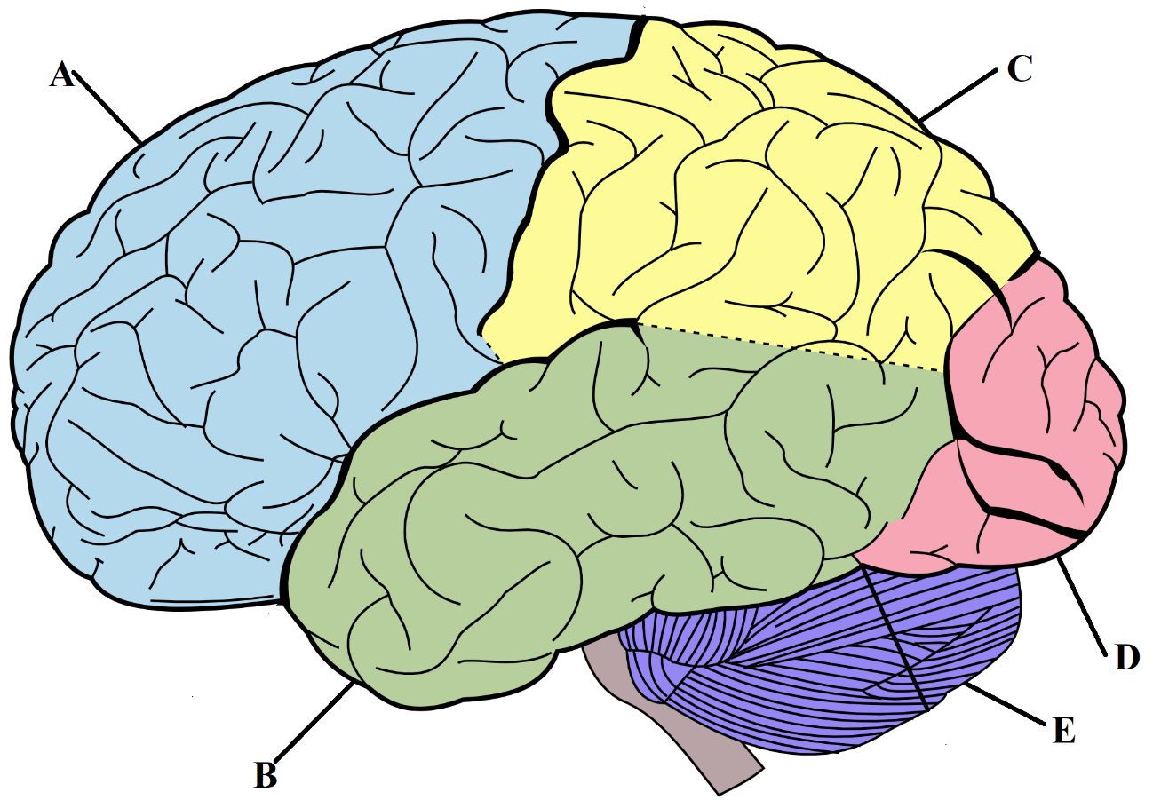

- Which label shows the parietal lobe?

  - A
  - B
  - C
  - D

- What is the function of E?

  - to coordinate motor functions
  - transfers information between the left and right hemispheres
  - controls body temperature
  - regulate thirst and hunger impulses

- What could result from damage to D?

  - disturbances of vision
  - inability to initiate voluntary movement
  - loss of hearing
  - sensitivity to temperature changes

- The part of the brain most associated with the regulation of thirst.

  - medulla oblongata
  - cerebrum
  - cerebellum
  - hypothalamus

- Which is the best definition of “accuracy” according to the scientific method?

  - baseline data to compare experiment results to
  - the extent to which an experiment produces consistent results
  - the extent to which a concept is correctly and precisely measured
  - the extent to which the hypothesis is tested by the method

- How do bacteriostatic antibiotics act on bacteria?

  - they kill the bacteria
  - they slow bacterial growth or reproduction
  - they inhibit cell wall synthesis
  - they dehydrate the bacteria

- What is the refractory period in an action potential?

  - the time it takes for threshold to be reached
  - the time following stimulation where the neuron cannot be stimulated again
  - the time it takes for the action potential to pass through the axon
  - the period where the membrane charges switch

- Which of the following comparisons describing the differences between the anterior and posterior pituitary is correct?

 | Anterior Pituitary | Posterior Pituitary
(a) | Produces oxytocin | Produces Follicle Stimulating Hormone (FSH)
(b) | Connects to the hypothalamus via capillaries | Connects to the hypothalamus via nerve axons
(c) | Releases hormones only | Produces and releases hormones
(d) | Released fewer hormones than posterior pituitary | Releases more hormones that anterior pituitary

- A researcher was testing the hypothesis:
“A low-sodium diet reduces blood pressure in people over 50 years old”
The independent variable in this experiment was the:

  - age of the subjects.
  - total kilojoule consumed daily.
  - blood pressure.
  - low-sodium diet.

Section Two: Short answer 50% (100 Marks)

This section has nine questions. Answer all questions. Write your answers in the spaces provided.

Supplementary pages for planning/continuing your answers to questions are provided at the end of this Question/Answer booklet. If you use these pages to continue an answer, indicate at the original answer where the answer is continued, i.e. give the page number.

Suggested working time: 90 minutes.

Question 31 (18 marks)

Alzheimer’s disease is a degenerative neurological disease that causes a loss of memory and thinking skills in sufferers. There is currently no effective treatment for this disorder though clinical trials are being conducted using cell-replacement therapy.

One such clinical trial is being conducted where Alzheimer’s patients have stem-cells transplanted into parts of their brain that have been damaged by the disease. Before this surgery occurs a large amount of cognitive reasoning and memory tests are given to establish a baseline level of damage. These tests are then conducted on the patient post-surgery every month to monitor progress.

- Propose an appropriate hypothesis for this investigation. (1 mark)

______________________________________________________________________________________________________________________________________

- Name the independent and dependent variables in this experiment. (2 marks)

______________________________________________________________________________________________________________________________________

- Define the term ‘control group’ and suggest a reason why a control group was not used in this study.
(2 marks)

_________________________________________________________________________________________________________________________________________________________________________________________________________

- State three variables that would need to be controlled to ensure a fair test.
(3 marks)

_________________________________________________________________________________________________________________________________________________________________________________________________________

The score for the memory tests and cognitive reasoning tests were aggregated into a percentage.

 | Patient 1 (%) | Patient 2  (%) | Patient 3  (%)
Before surgery | 12 | 15 | 17
1-month post-surgery | 13 | 14 | 17
2-month post-surgery | 17 | 19 | 20
3-month post-surgery | 22 | 25 | 25
4-month post-surgery | 32 | 29 | 28

- Calculate the mean test score for the three patients at 4-months post-surgery.
(1 mark)

_________________________________________________________________

- Use the grid below to construct a line graph for patient 1. (5 mark)


- Using your knowledge of cell-replacement therapy, suggest why improvement following this procedure has been so slow. (2 marks)

____________________________________________________________________________________________________________________________________________________________________________________________________________________________________________________________________________

- State a suitable conclusion that could be made based on the results of this study.
(2 marks)

____________________________________________________________________________________________________________________________________________________________________________________________________________________________________________________________________________
Question 32 (9 marks)

Use the diagram below to answer the following questions.

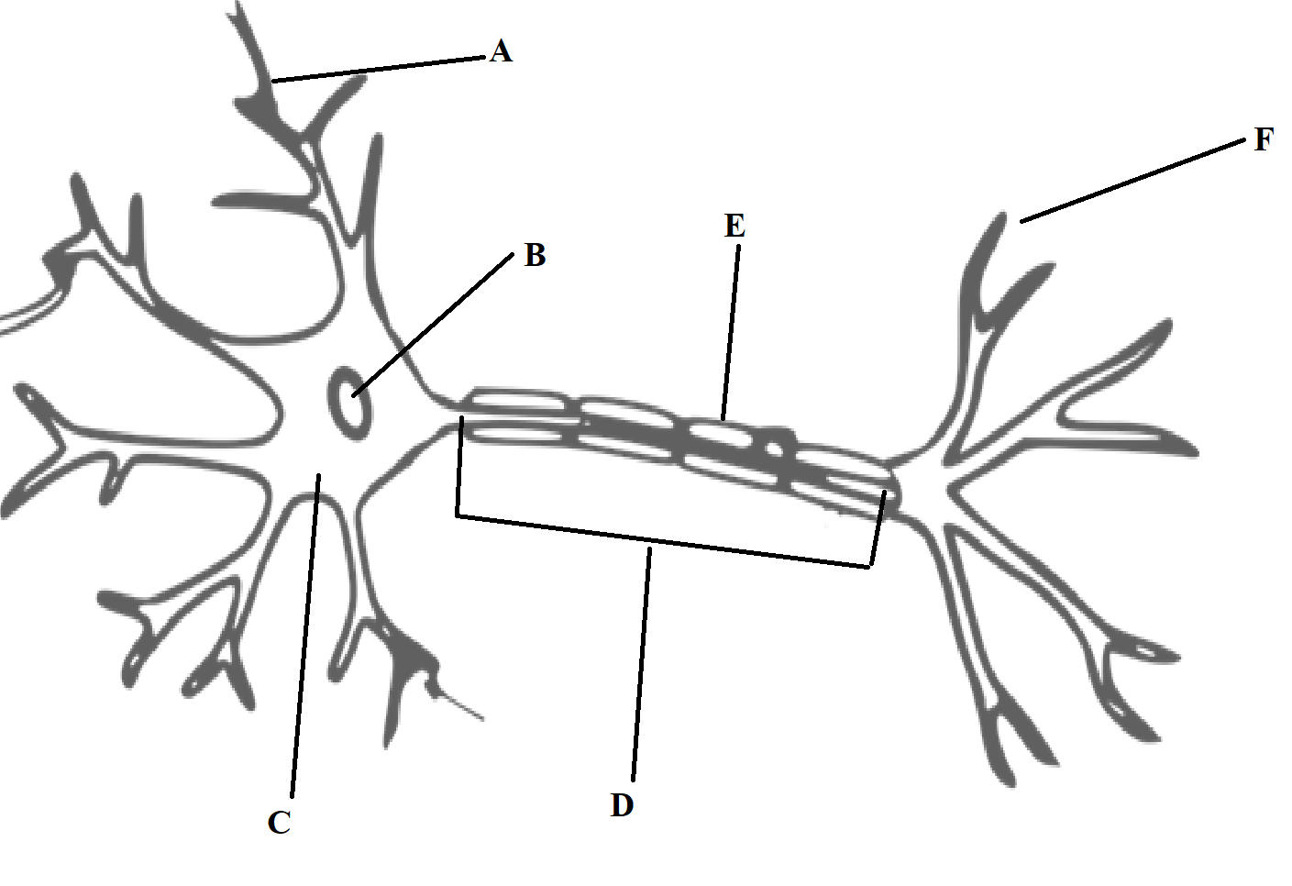

- Name the following structures. (2 marks)

A:__________________________________________________________________

B:__________________________________________________________________

- Describe the function of the following structures. (4 marks)

C:_____________________________________________________________________________________________________________________________________
___________________________________________________________________

D:________________________________________________________________________________________________________________________________________________________________________________________________________

- Describe the process that results in neurotransmitters being released from part F.
(3 marks)

_________________________________________________________________________________________________________________________________________________________________________________________________________

Question 33 (15 marks)

The diagram below shows the glands of the endocrine system.

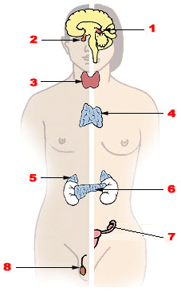

- Name the endocrine organs numbered below and for each one, give an example of one hormone it releases. (6 marks)

2:_____________________________________________________________________________________________________________________________________ 3:_____________________________________________________________________________________________________________________________________
4:_____________________________________________________________________________________________________________________________________

- Complete the table below to identify the target organ/s and the effect on the body of the following hormones. (6 marks)

Hormone | Target organ/s | Effect on the Body
Testosterone
Oxytocin

Growth Hormone

- Describe one effect on the body for the overproduction of each of the following hormones. (3 marks)

Thyroxine:
_________________________________________________________________________________________________________________________________________________________________________________________________________
Oestrogen:
_________________________________________________________________________________________________________________________________________________________________________________________________________
Aldosterone:
_________________________________________________________________________________________________________________________________________________________________________________________________________

Question 34 (5 marks)

Addison’s disease is an endocrine disorder where sufferers fail to produce enough of the hormone cortisol.

- Name the organ of the endocrine system that would be affected by Addison’s disease.
(1 mark)

___________________________________________________________________

- Describe the role of Adrenocorticotrophic Hormone (ACTH) on maintaining normal cortisol levels in the blood. (4 marks)

_______________________________________________________________________________________________________________________________________________________________________________________________________________________________________________________________________________________________________________________________________________

Question 35 (12 marks)

Fugu is a Japanese dish that is made from the pufferfish. While this dish is very sought after it needs to be prepared carefully as large parts of the pufferfish contain a neurotoxin called Tetrodotoxin (TTX). If TTX is ingested, it binds to Sodium ion (Na⁺) channels in the neuron, preventing them from transporting Na⁺ across the membrane, causing the cells to fail to reach threshold and signal an action potential. People then experience paralysis and cardiac arrest.

- What does the term threshold mean in terms of an action potential? Explain how this threshold is reached. (4 marks)

_____________________________________________________________________________________________________________________________________________________________________________________________________________________________________________________________________________________________________________________________________________________________________________________________________________________________________________________________________________________

- Information is passed from the pre-synaptic neuron to the dendrites using neurotransmitters. Explain how neurotransmitters transmit the impulse across a synapse. (3 marks)

____________________________________________________________________________________________________________________________________________________________________________________________________________________________________________________________________________

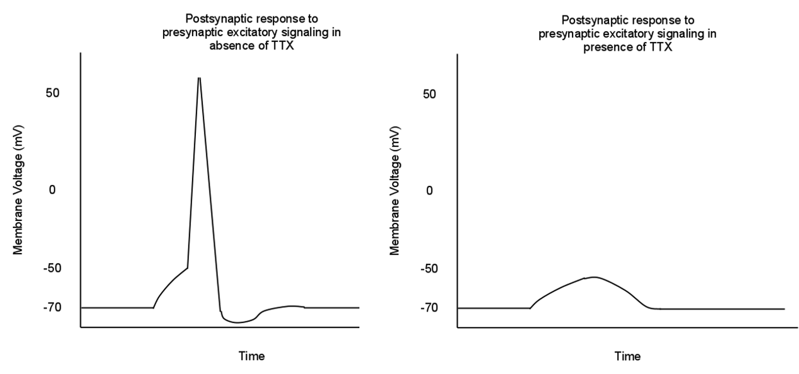
Use the diagram below to answer questions 35 c

- TTX affects the neurons by stopping Na⁺ from entering the cell. Referring to the diagram above, explain why neurotransmission fails. (2 marks)
_______________________________________________________________________________________________________________________________________________________________________________________________________________________________________________________________________________________________________________________________________________

- There is no antidote for TTX but people who have ingested it are sometimes given Atropine which is a drug that can stimulate the sympathetic nervous system to try and counter the effects of TTX. What are three changes that could occur in someone who has been treated with Atropine? (3 marks)
_______________________________________________________________________________________________________________________________________________________________________________________________________________________________________________________________________________________________________________________________________________
Question 36 (8 marks)

Herpes simplex labialis is a pathogen that causes recurrent outbreaks of cold-sores to those that are infected with this virus. It is estimated that between 50%-80% of humans have this virus.

- Herpes simplex labialis is a virus. List three structural characteristics of a virus. (3 marks)

One:_______________________________________________________________Two:_______________________________________________________________Three:______________________________________________________________

- Herpes can be spread from those infected to those who are not infected by contact with the saliva or fluids from the blister when the sufferer is having an outbreak. Outline three steps that a person with an active cold-sore could take to avoid passing on the Herpes virus to the non-infected. (3 marks)

One:________________________________________________________________________________________________________________________________________________________________________________________________________________________________________________________________________Two:________________________________________________________________________________________________________________________________________________________________________________________________________________________________________________________________________Three:_______________________________________________________________________________________________________________________________________________________________________________________________________________________________________________________________________

- Cold-sore outbreaks due to Herpes can be treated with topical antiviral medication. State how these antiviral medicines work to suppress the viral outbreak.

(2 marks)

_________________________________________________________________________________________________________________________________________________________________________________________________________

Question 37 (10 marks)

Allie was daydreaming about what she would have for dinner and accidently walked in front of a truck. She looked up just in time to jump out of the way of the truck before being hit.

- The photoreceptors in her eyes allowed Allie to see the truck. Name the receptor that Allie used to feel the heat of the exhaust as the truck drove past. (1 mark)

___________________________________________________________________

- Explain how the heat of the truck was processed through this receptor to be recognised by Allie’s Central Nervous System. (4 marks)

__________________________________________________________________________________________________________________________________________________________________________________________________________________________________________________________________________________________________________________________________________________________________________________________________________________

Question 37 (c-d) refers to the diagram of the reflex arc below.
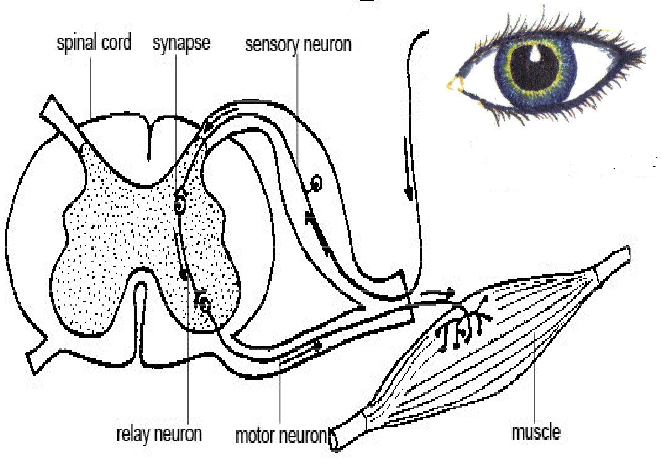

- When Allie responded to the truck, she blinked without being consciously aware of it. Outline how this was possible. (2 marks)

____________________________________________________________________________________________________________________________________________________________________________________________________________________________________________________________________________

- On the diagram highlight the afferent pathway of the reflex arc.
(1 mark)

- Sufferers of Motor Neuron Disease have a breakdown of structure and function of the motor neuron. If Allie had been suffering from this condition, describe how the reflex arc would have been different when she saw the truck.

(2 marks)

_____________________________________________________________________________________________________________________________________________________________________________________________________________________________________________________________________________________________________________________________________________________________________________________________________________________________________________________________________________________

Question 38 (9 marks)

Homeostasis is the maintenance of internal body conditions within tolerance limits. It involves behavioural and physiological activities.

- Describe two physiological responses to increased levels of blood sugar in the body. (2 marks)

____________________________________________________________________________________________________________________________________________________________________________________________________________________________________________________________________________

- Describe two behavioural responses to a decrease in body temperature. (2 marks)

____________________________________________________________________________________________________________________________________________________________________________________________________________________________________________________________________________

- Temperature regulation and blood sugar regulation are controlled by negative feedback. What does this mean? (1 mark)

_________________________________________________________________________________________________________________________________________________________________________________________________________

- Fever is an example of positive feedback. Describe the fever response and discuss why the body might initiate this response. (4 marks)

__________________________________________________________________________________________________________________________________________________________________________________________________________________________________________________________________________________________________________________________________________________________________________________________________________________
Question 39 (14 marks)

A runner ran in a 1500 metre race. After the race she noticed that her breathing rate was much faster than usual, but returned to a normal rate a few minutes after she finished.

- Name and state the location in the body of the structures involved in the homeostatic control of breathing. (4 marks)

____________________________________________________________________________________________________________________________________________________________________________________________________________________________________________________________________________

- What is the modulator for the homeostatic control of breathing? (1 marks)

___________________________________________________________________

- Exercise increases cellular respiration which decreases the pH of the blood. Explain how this happens? (3 mark)

_______________________________________________________________________________________________________________________________________________________________________________________________________________________________________________________________________________________________________________________________________________

- Increased heat produced during exercise can be removed from the body in several ways. Name and describe three methods of heat loss. (6 marks)

_____________________________________________________________________________________________________________________________________________________________________________________________________________________________________________________________________________________________________________________________________________________________________________________________________________________________________________________________________________________
Section Three: Extended answer 20% (40 Marks)

This section contains four questions. You must answer two questions.
Answer one question from 40 and 41 and one question from 42 and 43.

Responses could include clearly labelled diagrams with explanatory notes; lists of points with linking sentences; clearly labelled tables and graphs; and annotated flow diagrams with introductory notes.

Supplementary pages for planning/continuing your answers to a question are provided at the end of this Question/Answer booklet. If you use these pages to continue an answer, indicate at the original answer where the answer is continued, i.e. give the page number.

Suggested working time: 50 minutes.

Answer one question from Questions 40 to 41.

Indicate the questions you will answer by ticking the box next to the question. Write your answers on pages that follow.

Question 40 (20 marks)

Production of testosterone is controlled by genes that are stimulated in males during puberty.

- Testosterone is released by the gonads, but its production is controlled by the pituitary gland and the hypothalamus. Describe the pathway for the production of testosterone. (6 marks)

- Testosterone is a lipid-soluble hormone. Explain how testosterone enters and affects the functioning of its target cell. (6 marks)

- The other type of hormones the body releases are water soluble hormones. Describe how these hormones enter and affect the functioning of the target cell. (4 marks)

- Compare and contrast water-soluble and lipid soluble hormones with respect to their action within the body. (4 marks)

Question 41 (20 marks)

In 2007 a woman entered a competition where participants had to drink 240mL of water every 15 minutes without urinating. She came second and later died due to water intoxication.

- Describe the homeostatic mechanism that occurs when water levels in the blood increase. (10 marks)

- What would happen to the cells the in the blood stream if the fluid increased but was not allowed to be released.
(4 marks)

- A person was in a hot dry environment with a limited water supply. Describe the hormonal response that would occur to conserve fluid levels in their blood.
(6 marks)

Answer one question from Questions 42 to 43.

Indicate the questions you will answer by ticking the box next to the question. Write your answers on pages that follow.

Question 42 (20 marks)

Jessie was skateboarding when she fell and scraped her knee badly on some dirty gravel. To protect Jessie from pathogens, her body underwent a series of responses.

- Outline the inflammatory response that Jessie’s body would undergo as a result of her fall.
(6 marks)

- After the initial injury her body started to undergo the antibody mediated response. Outline this response.
(8 marks)

- Compare and contrast the antibody mediated response with the cell-mediated response. (6 marks)

Question 43 (20 marks)

The nervous system is divided into several sections based on structure and function.

- Compare and contrast the CNS and the PNS. (6 marks)

(ii) The PNS is divided into the somatic and autonomic divisions. What are the main features of the somatic division? (4 marks)

- On Christmas afternoon a person lays down on the couch following a large meal. Which division of the autonomic system would be engaged and what would the physiological effects on the person be?
(6 marks)

- This person has a sleep on the couch but wakes up when they feel something strange on their right elbow. They slap the elbow and open their eyes to discover a squashed mosquito. Outline the pathway of nerve impulses from feeling the mosquito to slapping the mosquito.
(4 marks)

END OF QUESTIONS

Question number: ________________
__________________________________________________________________________________________________________________________________________________
_________________________________________________________________________
_________________________________________________________________________
_________________________________________________________________________
_________________________________________________________________________
__________________________________________________________________________________________________________________________________________________
_________________________________________________________________________
_________________________________________________________________________
_________________________________________________________________________
_________________________________________________________________________
__________________________________________________________________________________________________________________________________________________
_________________________________________________________________________
_________________________________________________________________________
_________________________________________________________________________
_________________________________________________________________________
__________________________________________________________________________________________________________________________________________________
_________________________________________________________________________
_________________________________________________________________________
_________________________________________________________________________
_________________________________________________________________________
___________________________________________________________________________________________________________________________________________________________________________________________________________________________
Question number: ________________
__________________________________________________________________________________________________________________________________________________
_________________________________________________________________________
_________________________________________________________________________
_________________________________________________________________________
_________________________________________________________________________
__________________________________________________________________________________________________________________________________________________
_________________________________________________________________________
_________________________________________________________________________
_________________________________________________________________________
_________________________________________________________________________
__________________________________________________________________________________________________________________________________________________
_________________________________________________________________________
_________________________________________________________________________
_________________________________________________________________________
_________________________________________________________________________
__________________________________________________________________________________________________________________________________________________
_________________________________________________________________________
_________________________________________________________________________
_________________________________________________________________________
_________________________________________________________________________
_________________________________________________________________________
__________________________________________________________________________________________________________________________________________________
Question number: ________________
__________________________________________________________________________________________________________________________________________________
_________________________________________________________________________
_________________________________________________________________________
_________________________________________________________________________
_________________________________________________________________________
__________________________________________________________________________________________________________________________________________________
_________________________________________________________________________
_________________________________________________________________________
_________________________________________________________________________
_________________________________________________________________________
__________________________________________________________________________________________________________________________________________________
_________________________________________________________________________
_________________________________________________________________________
_________________________________________________________________________
_________________________________________________________________________
__________________________________________________________________________________________________________________________________________________
_________________________________________________________________________
_________________________________________________________________________
_________________________________________________________________________
_________________________________________________________________________
_________________________________________________________________________
__________________________________________________________________________________________________________________________________________________
Question number: ________________
__________________________________________________________________________________________________________________________________________________
_________________________________________________________________________
_________________________________________________________________________
_________________________________________________________________________
_________________________________________________________________________
__________________________________________________________________________________________________________________________________________________
_________________________________________________________________________
_________________________________________________________________________
_________________________________________________________________________
_________________________________________________________________________
__________________________________________________________________________________________________________________________________________________
_________________________________________________________________________
_________________________________________________________________________
_________________________________________________________________________
_________________________________________________________________________
__________________________________________________________________________________________________________________________________________________
_________________________________________________________________________
_________________________________________________________________________
_________________________________________________________________________
_________________________________________________________________________
_________________________________________________________________________
__________________________________________________________________________________________________________________________________________________
Question number: ________________
__________________________________________________________________________________________________________________________________________________
_________________________________________________________________________
_________________________________________________________________________
_________________________________________________________________________
_________________________________________________________________________
__________________________________________________________________________________________________________________________________________________
_________________________________________________________________________
_________________________________________________________________________
_________________________________________________________________________
_________________________________________________________________________
__________________________________________________________________________________________________________________________________________________
_________________________________________________________________________
_________________________________________________________________________
_________________________________________________________________________
_________________________________________________________________________
_________________________________________________________________________
_________________________________________________________________________
_________________________________________________________________________
_________________________________________________________________________
_________________________________________________________________________
__________________________________________________________________________________________________________________________________________________
__________________________________________________________________________________________________________________________________________________
Question number: ________________
__________________________________________________________________________________________________________________________________________________
_________________________________________________________________________
_________________________________________________________________________
_________________________________________________________________________
_________________________________________________________________________
__________________________________________________________________________________________________________________________________________________
_________________________________________________________________________
_________________________________________________________________________
_________________________________________________________________________
_________________________________________________________________________
__________________________________________________________________________________________________________________________________________________
_________________________________________________________________________
_________________________________________________________________________
_________________________________________________________________________
_________________________________________________________________________
__________________________________________________________________________________________________________________________________________________
_________________________________________________________________________
_________________________________________________________________________
_________________________________________________________________________
__________________________________________________________________________________________________________________________________________________
__________________________________________________________________________________________________________________________________________________
Question number: ________________
__________________________________________________________________________________________________________________________________________________
_________________________________________________________________________
_________________________________________________________________________
_________________________________________________________________________
_________________________________________________________________________
__________________________________________________________________________________________________________________________________________________
_________________________________________________________________________
_________________________________________________________________________
_________________________________________________________________________
_________________________________________________________________________
__________________________________________________________________________________________________________________________________________________
_________________________________________________________________________
_________________________________________________________________________
_________________________________________________________________________
_________________________________________________________________________
__________________________________________________________________________________________________________________________________________________
_________________________________________________________________________
_________________________________________________________________________
_________________________________________________________________________
_________________________________________________________________________
_________________________________________________________________________
__________________________________________________________________________________________________________________________________________________
Additional Working
__________________________________________________________________________________________________________________________________________________
_________________________________________________________________________
_________________________________________________________________________
_________________________________________________________________________
_________________________________________________________________________
__________________________________________________________________________________________________________________________________________________
_________________________________________________________________________
_________________________________________________________________________
_________________________________________________________________________
_________________________________________________________________________
__________________________________________________________________________________________________________________________________________________
_________________________________________________________________________
_________________________________________________________________________
_________________________________________________________________________
_________________________________________________________________________
__________________________________________________________________________________________________________________________________________________
_________________________________________________________________________
_________________________________________________________________________
_________________________________________________________________________
_________________________________________________________________________
_________________________________________________________________________
__________________________________________________________________________________________________________________________________________________
Additional Working
__________________________________________________________________________________________________________________________________________________
_________________________________________________________________________
_________________________________________________________________________
_________________________________________________________________________
_________________________________________________________________________
__________________________________________________________________________________________________________________________________________________
_________________________________________________________________________
_________________________________________________________________________
_________________________________________________________________________
_________________________________________________________________________
__________________________________________________________________________________________________________________________________________________
_________________________________________________________________________
_________________________________________________________________________
_________________________________________________________________________
_________________________________________________________________________
__________________________________________________________________________________________________________________________________________________
_________________________________________________________________________
_________________________________________________________________________
_________________________________________________________________________
_________________________________________________________________________
_________________________________________________________________________
__________________________________________________________________________________________________________________________________________________

ACKNOWLEDGEMENTS

Question 10 Adapted from Neuron [image] retrieved 9 December, 2020 from https://search.creativecommons.org/photos/7a4312df-fc7b-43dd-928c-e4ff32519bde

Question 13 Adapted from image retrieved 24 February, 2020 from https://en.wikipedia.org/wiki/Pituitary_gland#/media/File:1806_The_Hypothalamus-Pituitary_Complex.jpg

Question 17 Neuromuscular junction [image] retrieved 16 January, 2020 from https://en.wikipedia.org/wiki/Neuromuscular_junction

Question 22 Adapted from brain image retrieved 16 December, 2020 from https://upload.wikimedia.org/wikipedia/commons/2/23/Brain_diagram_without_text.svg

Question 32 Adapted from Neuron [image] retrieved 9 December, 2020 from https://upload.wikimedia.org/wikipedia/commons/0/00/Sketch_of_a_brain_neuron.png

Question 33 Adapted from endocrine system [image] retrieved 15 December, 2020 from: https://upload.wikimedia.org/wikipedia/commons/d/da/Illu_endocrine_system_heb_%28cropped%29.PNG

Question 35 TTX [graph] retrieved 5 December, 2020 from: https://en.wikipedia.org/wiki/Neurotoxin#/media/File:Tetrodotoxin_AP.png

